

Pabna University of Science and
TECHNOlOGY
INFORMATION AND COMMUNICATION ENGINEERING

Course Name: Signals and Systems Sessional
Course Code: ICE-2204
Submitted To,
dr.Md.Imran hossain
Associate PROFESSOR DEpARTMENT OF ICE, PUST
Submitted By, MD.MURSAlIN LEMON Roll: 220606 SESSION:2021-22
2nd Year 2nd Semester
DEpARTWENT OF ICE, PUST

Index | Title
01 | Plot the following signal operations using user defined function -  - adding ,b. multiplication, c. Scaling, d. shifting and e. folding.
02 | Explain and Implementation the unit Impulse sequence, the unit Step sequence, the unit Ramp sequence.
03 | Explain and Implement convolution of signal.
04 | Explain and Implement correlation of signal.
05 | Extract relevant features such as filtering, feature extraction, pick detection, heart rate etc. from PPG signal.
06 | Explain and Implement Discrete Fourier Transform (DFT) using python.

Lab Report on Signal Operations
Theory

Signal processing involves manipulating signals to extract information, enhance features, or analyze behavior. Basic operations like addition, multiplication, scaling, and shifting are fundamental in understanding signal behavior in both time and frequency domains.

- Signal Addition: Combining two or more signals, often used in overlaying or superimposing information.

y(t) = x1(t) + x2(t)
- Signal Multiplication: Multiplying two signals results in a combined signal with modulated characteristics, often used in amplitude modulation.

y(t) = x1(t) * x2(t)
- Scaling: Modifying the amplitude or duration of a signal.
  - Amplitude Scaling: Changes the signal's magnitude by a constant.
  - Time Scaling: Compresses or expands the signal along the time axis.

y(t) = k * x(at)
- Shifting: In this operation, each sample of x(n) is shifted by an amount k to obtain a shifted sequence y(n).

y(n)={x(n−k)}
If we let m = n−k, then n = m+k and the above operation is given by

y(m+k) = {x(m)}

These operations help in signal transformation, modulation, and system analysis.
- Folding: In this operation each sample of x(n)is flipped around n =0 to obtain a folded sequence y(n).

y(n)={x(−n)}

Source Code

import numpy as np
import matplotlib.pyplot as plt

# Parameters
t = np.arange(-10, 10, 0.01) # Time vector # Define two signals
x1 = np.sin(2 * np.pi * 1 * t) # Signal 1: Sine wave
x2 = np.cos(2 * np.pi * 0.5 * t) # Signal 2: Cosine wave # Signal Addition
y_add = x1 + x2
# Signal Multiplication y_mult = x1 * x2
# Amplitude Scaling
k = 2 # Scaling factor y_scaled = k * x1
# Time Shifting
shift = 2 # Shift value (in seconds)
y_shifted = np.sin(2 * np.pi * 1 * (t - shift)) # Delayed signal # Signal Folding
y_folded = np.sin(2 * np.pi * 1 * (-t)) # Folded sine wave # Plot Results
plt.figure(figsize=(12, 15)) # Original Signals plt.subplot(6, 1, 1)
plt.plot(t, x1, label='x1: Sine Wave', color='b') plt.plot(t, x2, label='x2: Cosine Wave', color='r') plt.title('Original Signals')
plt.legend()
plt.grid()
# Signal Addition plt.subplot(6, 1, 2) plt.plot(t, y_add, color='m') plt.title('Signal Addition') plt.grid()
# Signal Multiplication plt.subplot(6, 1, 3) plt.plot(t, y_mult, color='k')
plt.title('Signal Multiplication') plt.grid()
# Amplitude Scaling plt.subplot(6, 1, 4)
plt.plot(t, y_scaled, color='g') plt.title('Amplitude Scaling') plt.grid()
# Time Shifting plt.subplot(6, 1, 5)
plt.plot(t, y_shifted, color='c') plt.title('Time Shifting') plt.grid()
# Signal Folding plt.subplot(6, 1, 6)
plt.plot(t, y_folded, label='Folded Signal', color='purple') plt.title('Signal Folding')
plt.legend() plt.grid()

# Display the plots plt.tight_layout() plt.show()
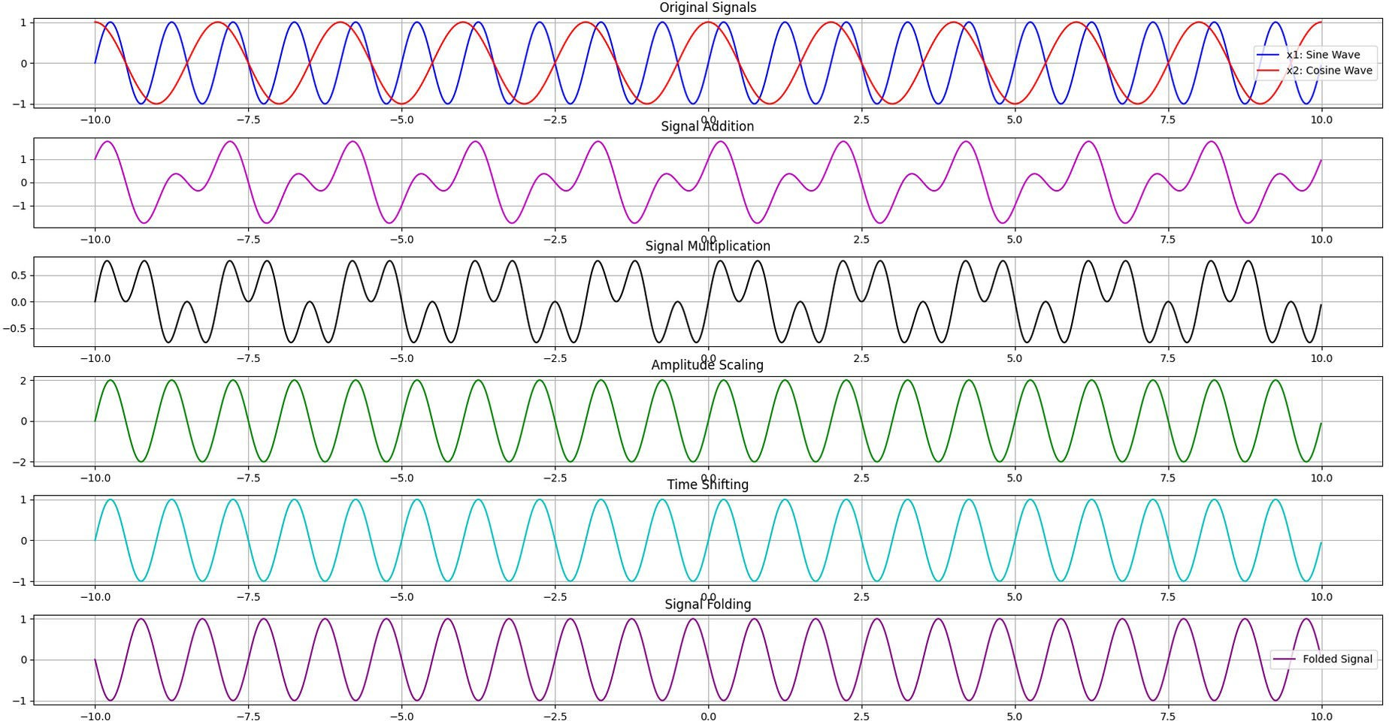
Output

Lab Report on Signal Sequence

Theory
Signal sequences are fundamental building blocks in signal processing and system analysis. They are used to represent basic signals that can be combined or manipulated to model more complex systems. In this lab, we focus on three key signal sequences:
- Impulse Signal:
  - The impulse signal, also known as the Dirac delta function, is a theoretical signal that is zero everywhere except at t=0, where it is infinitely high. In practice, it is approximated as a narrow pulse with unit area.
  - Mathematically, the impulse signal is defined as:

δ(t)={∞ if t=0
0 otherwise

  - The impulse signal is used to analyze the response of systems (impulse response) and is a key concept in convolution and filtering.
- Step Signal:
  - The step signal, also known as the unit step function, represents a signal that transitions from 0 to 1 at t=0.
  - Mathematically, the step signal is defined as:

1 if t≥0
{
u(t)=

0 otherwise

  - The step signal is used to model systems that switch on at a specific time, such as turning on a device or applying a constant input.
- Ramp Signal:
  - The ramp signal represents a signal that increases linearly with time for t≥0.
  - Mathematically, the ramp signal is defined as:

r(t)={t if t≥0
0 otherwise
  - The ramp signal is used to model systems with linearly increasing inputs, such as velocity or acceleration.

Source Code
import numpy as np
import matplotlib.pyplot as plt

# Define the range for continuous-time signals
t = np.linspace(-10, 10, 1000) # Smooth time values

# Define continuous-time signals def impulse_signal(t):
return np.where(np.abs(t) < 0.1, 1, 0) # Approximate impulse with a narrow pulse

def step_signal(t):
return np.where(t >= 0, 1, 0)

def ramp_signal(t):
return np.where(t >= 0, t, 0)

# Generate signals
impulse = impulse_signal(t) step = step_signal(t)
ramp = ramp_signal(t)

# Plot signals plt.figure(figsize=(12, 4))

# Impulse Signal
plt.subplot(1, 3, 1)
plt.plot(t, impulse, 'r', linewidth=2) plt.title("Impulse Signal (Approximate)") plt.xlabel("t")
plt.ylabel("Amplitude") plt.grid()
# Step Signal plt.subplot(1, 3, 2)
plt.plot(t, step, 'g', linewidth=2) plt.title("Step Signal") plt.xlabel("t") plt.ylabel("Amplitude") plt.grid()
# Ramp Signal plt.subplot(1, 3, 3)
plt.plot(t, ramp, 'b', linewidth=2) plt.title("Ramp Signal") plt.xlabel("t") plt.ylabel("Amplitude")
plt.grid()

plt.tight_layout() plt.show()
Output

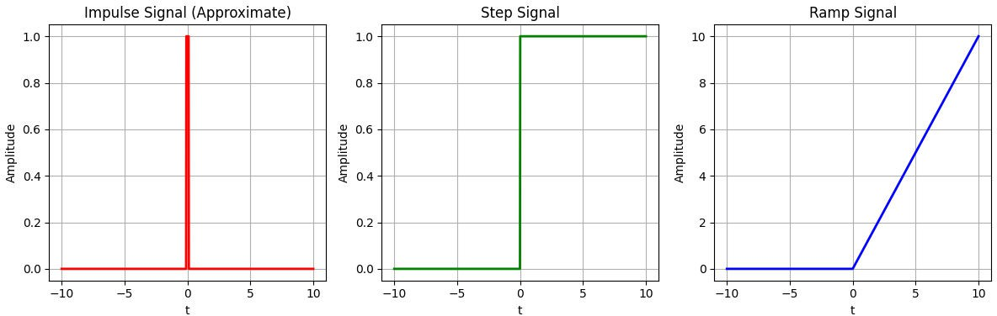
Lab Report on Convolution

Theory
Convolution is a mathematical operation that combines two signals to produce a third signal, which represents how the shape of one signal is modified by the other. It is a fundamental concept in signal processing, used in applications such as filtering, system analysis, and image processing.
The convolution of two continuous-time signals x(t) and h(t) is defined as:

y(t)=x(t)∗h(t)=−∞∫∞x(τ)h(t−τ)dτ

For discrete-time signals, the convolution is given by:

y[n]=x[n]∗h[n]=_{k=}−∞∑∞x[k]h[n−k]
Some properties of convolution:
- Linear Time-Invariant (LTI) Systems: Convolution is used to describe the output of an LTI system when the input signal and the system's impulse response are known.
- Commutative Property: Convolution is commutative, meaning x(t)∗h(t)=h(t)∗x(t).
- Applications: Convolution is used in filtering (e.g., low-pass, high-pass filters), audio processing, and image blurring or sharpening.
By performing convolution, we can analyze how a system responds to different inputs, design filters, and understand the interaction between signals and systems.

Source code
import numpy as np
import matplotlib.pyplot as plt

# Define two real signals: sine and cosine waves fs = 1000 # Sampling frequency in Hz
t = np.linspace(0, 1, fs, endpoint=False) # Time vector (1 second duration)

# Define the signals
sine_wave = np.sin(2 * np.pi * 5 * t) # 5 Hz sine wave cosine_wave = np.cos(2 * np.pi * 5 * t) # 5 Hz cosine wave

# Perform convolution
conv_result = np.convolve(sine_wave, cosine_wave, mode='full') # Display and plot the results
plt.figure(figsize=(12, 6))

# Original signals plt.subplot(3, 1, 1)
plt.plot(t, sine_wave, label="Sine Wave") plt.plot(t, cosine_wave, label="Cosine Wave") plt.title("Original Signals")
plt.legend() plt.grid()

# Convolution result
conv_time = np.linspace(-1, 1, len(conv_result), endpoint=False) plt.subplot(3, 1, 2)
plt.plot(conv_time, conv_result, label="Convolution", color='orange') plt.title("Convolution of Sine and Cosine Waves")
plt.xlabel("Time") plt.ylabel("Amplitude") plt.grid()

plt.tight_layout() plt.show()

Output
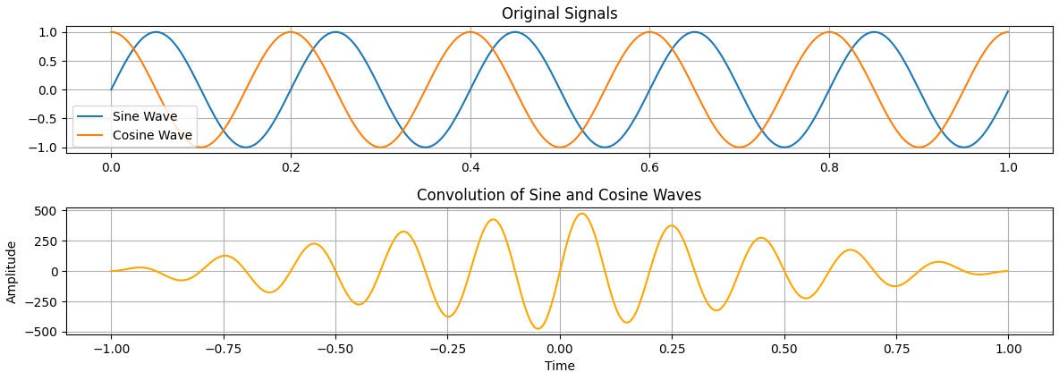

Lab Report on Correlation

Theory
Correlation is a measure of similarity between two signals, often used to detect patterns or align signals in time. It is widely used in applications such as radar, sonar, and pattern recognition.
The cross-correlation of two continuous-time signals x(t) and y(t) is defined as:
R_{xy}(τ)=−∞∫∞x(t)y(t+τ)dt

For discrete-time signals, the cross-correlation is given by:

R_{xy}[m]=_{n=}−∞∑∞x[n]y[n+m]
Some properties of correlation:
- Autocorrelation: When a signal is correlated with itself, it is called autocorrelation. It measures the similarity of a signal with a time-shifted version of itself.
- Applications: Correlation is used in signal detection, time-delay estimation, and pattern matching.
- Peak Detection: The peak of the correlation function indicates the time shift where the signals are most similar.
By using correlation, we can determine the degree of similarity between signals, detect delays, and identify patterns in noisy environments.

Source code
import numpy as np
import matplotlib.pyplot as plt

# Define two real signals: sine waves with different frequencies fs = 1000 # Sampling frequency in Hz
t = np.linspace(0, 1, fs, endpoint=False) # Time vector (1 second duration)

# Define the sine waves with different frequencies sine_wave1 = np.sin(2 * np.pi * 5 * t) # 5 Hz sine wave
sine_wave2 = np.sin(2 * np.pi * 5 * t + np.pi / 4) # 5 Hz sine wave with a phase shift of 45 degrees

# Display and plot the results plt.figure(figsize=(12, 8))

# Original signals
plt.subplot(3, 1, 1)
plt.plot(t, sine_wave1, label="Sine Wave 1 (5 Hz)")
plt.plot(t, sine_wave2, label="Sine Wave 2 (5 Hz with 45° phase shift)") plt.title("Original Signals (Sine Waves with Phase Shift)") plt.xlabel("Time (s)")
plt.ylabel("Amplitude") plt.legend()
plt.grid()

# Perform cross-correlation
correlation = np.correlate(sine_wave1, sine_wave2, mode='full')
lags = np.arange(-len(sine_wave1) + 1, len(sine_wave1)) # Compute lag indices

# Cross-correlation plt.subplot(3, 1, 2)
plt.plot(lags, correlation, label="Cross-Correlation", color='green') plt.title("Cross-Correlation of Sine Waves")
plt.xlabel("Lag") plt.ylabel("Correlation") plt.legend()
plt.grid()

# Perform auto-correlation
auto_correlation = np.correlate(sine_wave1, sine_wave1, mode='full')

# Auto-correlation plt.subplot(3, 1, 3)
plt.plot(lags, auto_correlation, label="Auto-Correlation", color='orange') plt.title("Auto-Correlation of Sine Wave 1")
plt.xlabel("Lag") plt.ylabel("Correlation") plt.legend()
plt.grid()
plt.tight_layout() plt.show()

Output
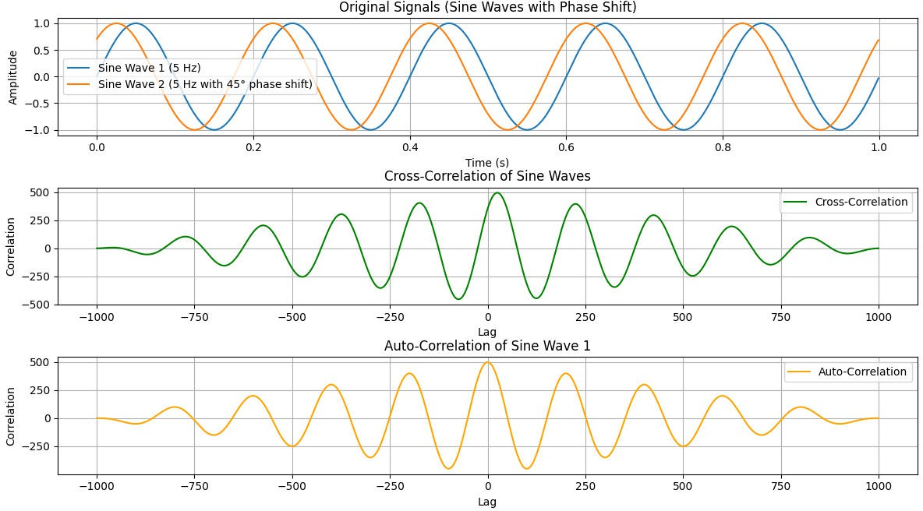

Lab report on Feature Extraction of a PPG (Photoplethysmogram) Signal

Theory:

Photoplethysmography (PPG) is a simple and non-invasive technique used to measure changes in blood volume in the body. It works by shining light onto the skin and detecting variations in the reflected or transmitted light, which correspond to blood flow changes. PPG signals are widely used in heart rate monitoring, oxygen saturation measurement, and cardiovascular health analysis.
Since the PPG signal contains valuable physiological information, we use feature extraction techniques to analyze it effectively. These techniques help us identify key characteristics such as heart rate, blood circulation patterns, and heart rate variability.

Understanding the PPG Signal

The PPG signal consists of repeating waveforms that represent heartbeats. Each cycle of the signal contains:
  - A Systolic Peak (Highest Point): This corresponds to the maximum blood volume in the arteries when the heart contracts.
  - A Diastolic Point (Lowest Point): This occurs when the blood volume is at its lowest before the next heartbeat.
The frequency of these peaks is directly related to heart rate, and their shape provides insights into blood circulation. However, the raw PPG signal can be noisy due to motion artifacts, ambient light, and sensor imperfections.

Preprocessing the PPG Signal (Filtering)

Before extracting features, the PPG signal must be cleaned to remove unwanted noise. This process involves:
  - Removing High-Frequency Noise: Using a low-pass filter to eliminate sudden spikes and artifacts.
  - Removing Slow Variations (Baseline Drift): Using a high-pass filter to focus on heartbeat-related changes.
  - Smoothing the Signal: Applying signal processing techniques to improve peak detection.
The cleaned signal is now ready for feature extraction.

Peak Detection and RR Interval Calculation
After filtering, we detect peaks in the PPG signal. These peaks represent heartbeats, and the time difference between two consecutive peaks is called the RR interval (measured in seconds).

RR Interval=Time between two successive peaks

By analyzing RR intervals, we can calculate:
  - Heart Rate (HR): The number of heartbeats per minute (BPM).

Interval (s)HR= 60 / RR Interval (s)

  - Heart Rate Variability (HRV): The variation in RR intervals, which provides insights into stress levels and cardiovascular health.

Other Important Features in PPG Signals
Apart from heart rate and RR intervals, we can extract additional features from the PPG signal:
  - Pulse Amplitude: The height difference between peaks and valleys, indicating blood flow strength.
  - Pulse Width: The time duration of each pulse, giving insights into arterial stiffness.
  - Pulse Slope: The rate at which blood flow increases or decreases.
These features are useful for diagnosing heart conditions and monitoring overall health.

Source code & Output:

import neurokit2 as nk import numpy as np
import matplotlib.pyplot as plt

# 1. Generate a synthetic PPG signal (replace this with real PPG data)
ppg_signal = nk.ppg_simulate(duration=30, sampling_rate=1000)

# Plot the original PPG signal plt.figure(figsize=(10, 4))
plt.plot(ppg_signal, label="Original PPG Signal") plt.title("Original PPG Signal")
plt.xlabel("Time (ms)") plt.ylabel("Amplitude") plt.legend()
plt.show()

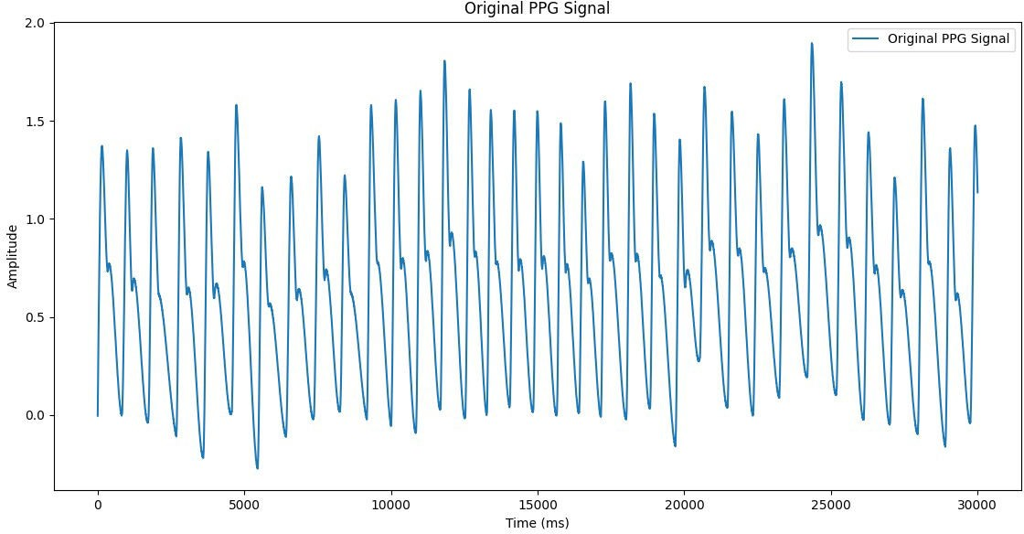

# 2. Filter the signal
ppg_filtered = nk.ppg_clean(ppg_signal, sampling_rate=1000)

# Plot the filtered PPG signal plt.figure(figsize=(10, 4))
plt.plot(ppg_filtered, label="Filtered PPG Signal", color="orange") plt.title("Filtered PPG Signal")
plt.xlabel("Time (ms)") plt.ylabel("Amplitude") plt.legend()
plt.show()
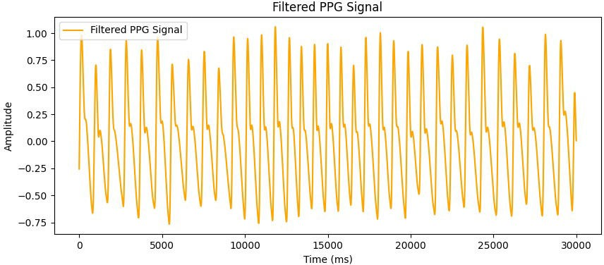

# 3. Detect Peaks
peaks = nk.ppg_findpeaks(ppg_filtered, sampling_rate=1000) peak_indices = peaks["PPG_Peaks"]

# Plot the filtered signal with detected peaks plt.figure(figsize=(10, 4))
plt.plot(ppg_filtered, label="Filtered PPG Signal", color="orange")
plt.scatter(peak_indices, ppg_filtered[peak_indices], color="red", label="Detected Peaks")
plt.title("Filtered PPG Signal with Detected Peaks") plt.xlabel("Time (ms)")
plt.ylabel("Amplitude") plt.legend()
plt.show()

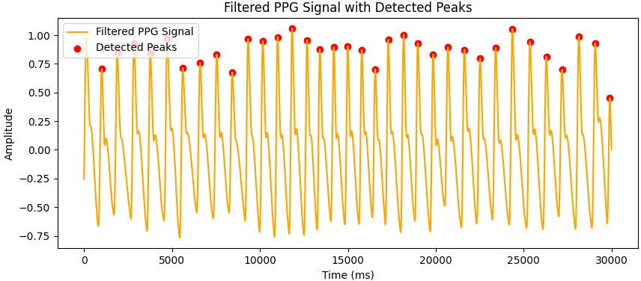

# 4. Calculate RR Intervals
rr_intervals = np.diff(peak_indices) / 1000 # Convert to seconds

# Plot RR intervals plt.figure(figsize=(10, 4))
plt.plot(rr_intervals, label="RR Intervals", color="green", marker="o") plt.title("RR Intervals (Seconds)")
plt.xlabel("Peak Index")
plt.ylabel("Interval (s)") plt.legend()

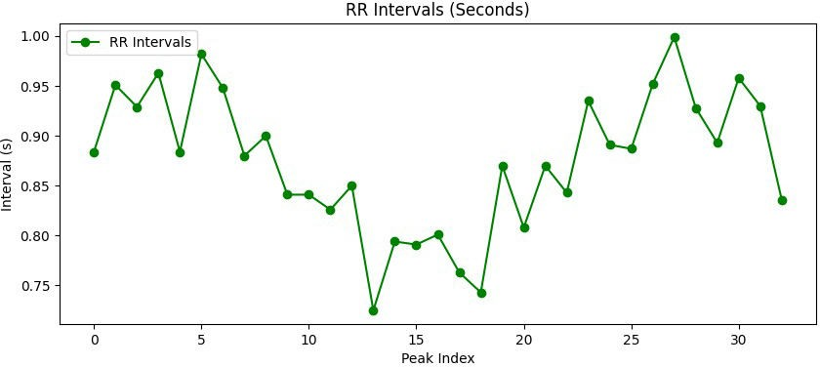
plt.show()

# 5. Calculate Heart Rate
heart_rate = 60 / rr_intervals # BPM

# Plot Heart Rate plt.figure(figsize=(10, 4))
plt.plot(heart_rate, label="Heart Rate (BPM)", color="purple", marker="o") plt.title("Heart Rate (BPM)")
plt.xlabel("Interval Index")
plt.ylabel("Heart Rate (BPM)") plt.legend()
plt.show()

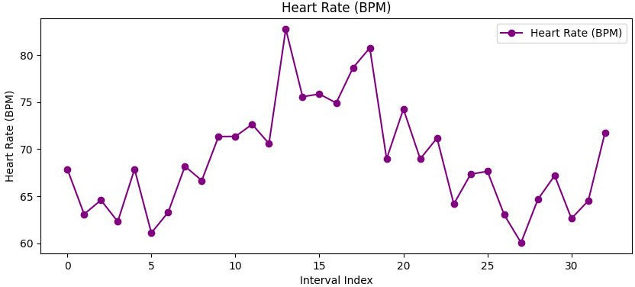

Lab Report on Discrete Fourier Transform (DFT)

Theory
The Discrete Fourier Transform (DFT) is a mathematical technique used to transform a discrete-time signal from the time domain into the frequency
domain. It is a fundamental tool in digital signal processing (DSP) and is widely used for analyzing the frequency content of signals, filtering, and spectral analysis.
The DFT of a discrete-time signal x[n] of length N is defined as:

X[k]=_{n=0}∑ N−1x[n]e−jN2πkn for k=0,1,2,…,N−1

where:
- X[k] is the DFT of the signal x[n], representing the frequency components.
- k is the frequency index.
- N is the total number of samples in the signal.
The inverse DFT (IDFT) is used to reconstruct the original signal from its frequency components and is given by:

x[n]=_{k=0}∑^{N−1}X[k]ejN2πkn for n=0,1,2,…,N−1

Some properties of DFT:
- Frequency Resolution: The frequency resolution of the DFT depends on the number of samples N and the sampling rate fs. The frequency resolution is given by Nfs.
- Periodicity: The DFT assumes that the signal is periodic with period N. This means that the signal repeats itself every N samples.
- Fast Fourier Transform (FFT): The FFT is an efficient algorithm to compute the DFT, reducing the computational complexity
from O(N2) to O(NlogN).

Applications:
  - Spectral Analysis: The DFT is used to analyze the frequency content of signals, such as audio, vibration, and biomedical signals.
  - Filtering: By transforming a signal into the frequency domain, unwanted frequency components can be filtered out.
  - Signal Compression: The DFT is used in compression algorithms like JPEG and MP3 to reduce the size of data by removing redundant frequency components.

Source code &Output:

import numpy as np
import matplotlib.pyplot as plt

def DFT(x):
"""
Compute the Discrete Fourier Transform (DFT) of a 1D signal. """
N = len(x)
X = np.zeros(N, dtype=complex) # Output array (complex numbers)

for k in range(N): # Loop over frequency bins
for n in range(N): # Loop over time samples
X[k] += x[n] * np.exp(-2j * np.pi * k * n / N)
return X

# Create a sample signal (two sine waves) Fs = 1000 # Sampling rate
T = 1 / Fs # Sampling interval
t = np.linspace(0, 1, Fs, endpoint=False) # 1 second duration

# Signal: Combination of 50 Hz and 120 Hz sine waves f1, f2= 50, 120 #f3=150
signal = np.sin(2 * np.pi * f1 * t) + 0.5 * np.sin(2 * np.pi * f2 * t) #+ 1.5 * np.sin(2 * np.pi * f3 * t)

plt.plot(t,signal) # Single-sided spectrum plt.title("Time domain signal") plt.xlabel("time")
plt.ylabel("amplitude") plt.grid()
plt.show()
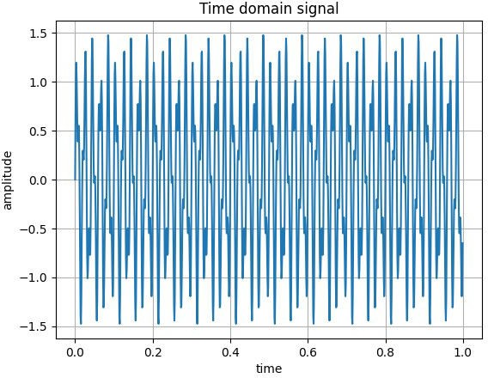

# Compute DFT dft_output = DFT(signal)
# Compute frequency bins
freqs = np.fft.fftfreq(len(dft_output), T)

# Plot magnitude spectrum (single-sided) plt.figure(figsize=(10, 5))
plt.plot(freqs[:Fs//2], np.abs(dft_output[:Fs//2])) # Single-sided spectrum plt.title("DFT Frequency Spectrum")
plt.xlabel("Frequency (Hz)") plt.ylabel("Magnitude") plt.grid()
plt.show()
